IPA Region 6 Fit Challenge 2026
March 2026

It has been 3 months since IPA Region 6 has re-started the Fit Challenge. Our goal is to circumnavigate the globe’s equator, for a distance of 40,075kms. After 3 months, Region 6 has 20 members, actually less, as some of the registrants are family members, which is permitted and encouraged.

Will we achieve our goal? With 20 people, it is indeed a difficult challenge. Totally understand our frozen Canadian winter months from coast to coast. Most of us detest the cold and hibernate, Even the month of March 2026, was extremely and unusually cold. Although most Canadian provinces experienced snow… still in April, greener pastures are coming, our Canadian snowbirds, the geese are pushing North and filling our skies with their famous V shaped honking cries of arrival. Even our Regional snowbirds, such as Jim Grant is slowly making his way back North, hoping to skip that white stuff. Again, we are calling for all Regional 6 members, there are well over 150 members, to register and even some kilometers is better than no kilometers. Every little bit counts and pushes us closer to our goal. You can exercise by yourself if you prefer your own company, or exercise with others, including regional members. Watch for summer events of getting together to walk, conduct some form of exercise as we stretch towards that 40,075kms goal. It is achievable. Region 6 circumnavigated the globe in 1.6 months back in 2023 – 2024. Please register my emailing IPAR6FitChallenge2026@outlook.com

Within the month of March 2026, our Fit Challenge members achieved 2,535.23kms, which is 500kms more than Feb 2026. Beginning at the Pacific Ocean, we have traversed ALMOST all of Canada and are only 800kms shy of touching the Atlantic Ocean. Note we are still missing monthly results from some of our registered members. Monthly reminders are sent out. Maybe with all the results we could be already splashing in the Atlantic Ocean. As it is, we are stuck in NS and waiting for the ferry to Newfoundland. Lobster season has begun in some Nova Scotia regions as of 01 April 2026, so we will blame the tempting and intoxicating lobster delicacy on the reason for the abrupt halt. We will be traversing the Atlantic Ocean, which is only 3,300kms from Newfoundland to Ireland…plus the last 800kms to reach the Atlantic Ocean for a total of 4,100kms. Can we do it? Absolutely, with as much help as possible and sending in your monthly results.
Our top Regional member is Bill Murrell, with a trail blazing superhuman effort of 816.98kms in one month. His top so far. Alone, Bill has accumulated 2,126.39kms! I cannot even count that high without falling asleep. Huge kudos Bill and bless your mighty heart! For a retired Regional member, you are sure making the positive impression! Bill has dedicated himself to using his stationary bicycle and rowing machine in his basement. We are not getting any complaints from his family yet, so do not know if that is a good thing. Most definitely an incredible challenge for our younger Regional members to meet or beat Bill’s monthly results. Again, congratulations Bill on your phenomenal feat and thank you for anchoring the team’s challenge.

Our next top contender, stepping way out this month is Andrea Lamothe, with a March 2026 result of 436kms! Andrea’s 3-month total is 802kms, past our Regional 710kms circumference. Andrea is training for a ½ marathon, and she reported her “Garmin” is showing absolutely no mercy. Good for you Andrea. We wish you every success in your upcoming marathon and keep going. Never stop!

The author has finally emerged from hibernation and in one week beat her monthly challenges from January to March. Here is hoping for success and most importantly more time out of the retirement home. For any Regional members in a retirement home, chair yoga and swimming exercises do count. We strongly encourage you to register and get in on the incredible feat. Send in whatever exercise you do with the length of time and the author will figure out the kilometer equivariant.

Doug and Jane Morris have continued their international trekking, finding themselves down under in Australia. Luckily, they missed the cyclone that continued to bash Queensland, Australia, not once, not twice, but three times, weaking onshore, then turning back out to the ocean to gather more strength and come back onto land. Doug’s pictures are from their walk in Sydney, Australia and now they are in Noosa, Queensland, Australia, Thanks for your pictures, Doug.
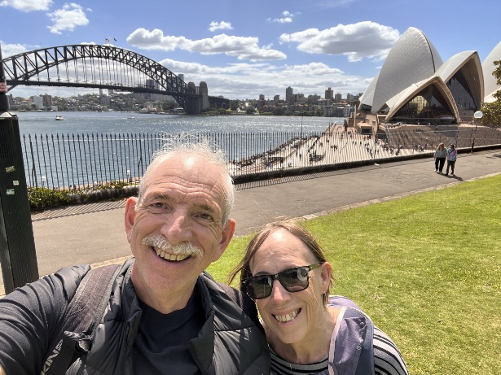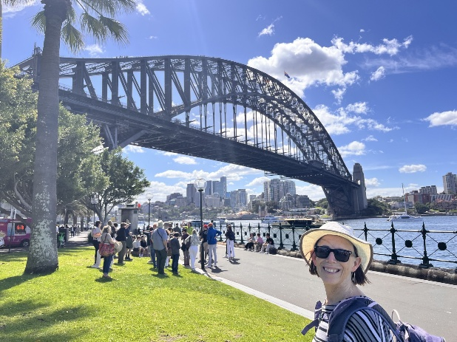
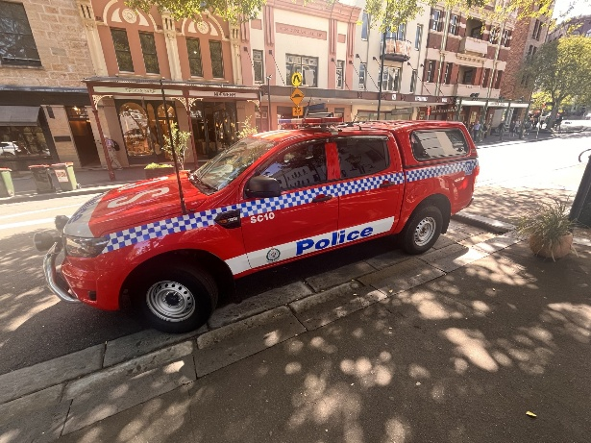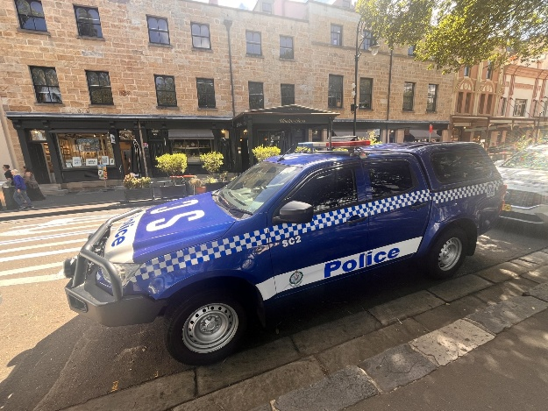

A reminder to all, we encourage your pictures when you send in your monthly results, not only to encourage others, but official bragging rights. I would most definitely prefer walking/hiking through Australia than hibernating in Ottawa during the month of March 2026.

Perhaps, another challenge we could incorporate within our Fit Challenge, is to send in the most different country, different provincial or even museum police vehicles you see throughout your kilometer challenge.

Yet another month of well-done results and huge kudos to all! For those of us getting warmed up, brighter, longer and nicer temperatures are just around the corner. Let’s beat our March 2026 record and traverse the Atlantic Ocean. We need 4,100kms! We can do it! Sign up and help us out. Let us show them what a police team can do! There are 100 plus of us that make up the region. Help us get across the ocean. We can, but only with your help.

