IPA REGION 6 FITNESS CHALLENGE
MAY 2026 REPORT

Region 6 has finally bid the end to a prolonged and wet winter. Spring did not bring the typical warm and bright days; however, it did bring the tulips. The editor has finally conceded it is high time to store away her cross country skies for a few months. The unseasonably cold spring managed to lower our average fit scores, but not our spirit. Collectively we have managed to cover 11, 058.13 kilometers! We have crossed all of Canada, traversed the tempestuous Atlantic Ocean and managed to end up in Poland. Pretty impressive for our first 6 months! Congratulations to all!
Now, we would probably be in Lativa or close to Russia, if all our team submitted their monthly stats. Reminder letters will be sent out as it seems to work best. Again, we are always looking for more IPA Region 6 members to assist in gathering kilometers. Our challenge is to circumnavigate the globe within one year, So far, we have just over 29,000kms to go. With more members we are able to achieve this feat. We also appreciate pictures along with your stats. Huge thanks to Doug and June Morris, for all of their wonderful pictures of their worldwide adventures.
Doug and June have found their way back to Canada and spent the month of May between British Columbia and Carleton Place, ON. They both look forward to their weekly 8 kilometer round trip to their local brewery, the first leg to the brewery is a constant uphill assent. Stop for a much deserved beer or two…maybe three and a hop and skip home, fueled by the beer.
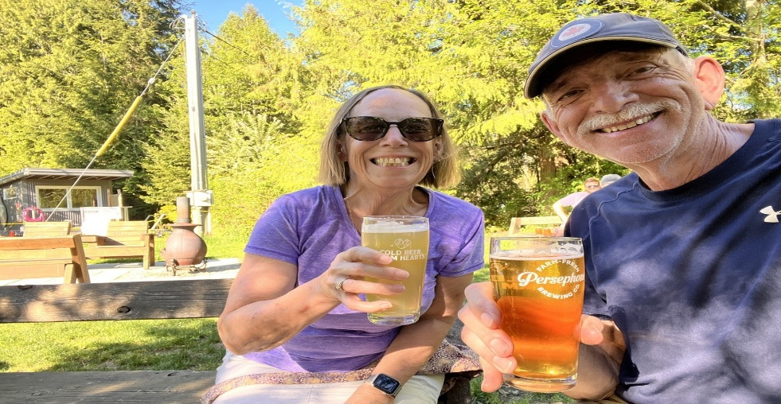
Special mention to Gilbert Anctil, who has managed to accumulate 1,607.36 kilometers. Gilbert focuses on walking, working out in the gym and even doing yoga. These times can be easily calculated into kilometers, so whatever is your passion, like Gilbert, each step, each stretch, each workout counts towards our goal. Thank you Gilbert and keep up the fantastic work!
Bill Murrell slowed down a bit during the month of May; however, he still easily maintains the lead with 3,171.18 kilometers. The Bionic Man has slightly paused and is gearing up for his summer activities such as dragon boat, basketball and outdoor bicycling. Bill, always appreciate your hard work and determination! Congratulations on your incredible feat!
Mike Pearson is a newcomer this year and he is also a strong contributor to our fit challenge, adding 817.7 kilometers to our overall score. Mike has circumnavigated our region 6 circumference and is well on his way of making it all across Canada. More importantly, we thank Mike for consistently sending in his monthly stats.
That is it for this month. Sign up at IPAR6FitChallenge2026@outlook.com and please submit your monthly stats. Even your past overdue stats will add to the team score.

