IPA REGION 6 FIT CHALLENGE 2026
APRIL 2026

IPA Region 6 is on their 4th month of the Global Circumference of the World Challenge. Having begun in British Columbia, IPA R6 participants have trekked the equivalent from British Columbia, “swam” across the Atlantic ocean, braving the winds, waves, sharks, submarines from who knows how many countries, avoided run-ins with international shipping lanes or blockades and are nearing the stupendous coastlines of Ireland! Well done everyone! The total so far traversed in 4 months is 9,559.39 kilometers. During the month of April, for those that submitted their scores, we have managed as a team, to yet again, surpass all the other months, with a total of 2996 kms!
What a team! Every kilometer counts and a gentle nudge for those participants who have yet to provide their stats. We will take them at any time but do appreciate the end of the month or first weekend of the next month so the report can be compiled.
Unfortunately, our call for more participants went unheeded. Again, with over 100 Regional 6 members, we sincerely appreciate every kilometer added to our challenge. It does not have to be a lot. Currently we only have 20 participants. Lots of room for more. The email is IPAR6FitChallenge2026@oytlook.com All are welcome. Include your family. Their scores are also welcome.
Our top contender is Bill Murrell, who must be running out of Netflix movies, as he managed to pedal a mere 690.35 kms. Bill states he zones out of his stationary bicycle and watches a movie while pedaling. I, personally, would most probably fall off during the thrilling or scary parts. Bravo Zulo Bill, once again and huge thanks for being our rock in obtaining our Regional goal. Some R6 members were out planting trees in April and we had difficulty keeping up to Bill as he dug the holes for the saplings. The man is a machine!
Another Region 6 member, who came so close to Bill’s April record was Gilbert Anctil, who walked, swam, lifted weights, added some gym workout and even yoga sessions, for a total of 670kms. Just a hair behind Bill. Excellent job Gilbert! Another Regional member who is always on the go.
Doug and Jane continue to trek all around Australia, from coast to coast. The weather was naturally much more pleasant and cooperative than up here in Ottawa – Cornwall - Kingston region. Doug and Jane managed to avoid run ins with all of Australia’s pleasant creatures such as the great white sharks, the nasty and huge spiders and snakes. Always “one step ahead” of the critters. Doug and Jane continue to add 100’s of kilometers each month. Thanks for the beautiful brag pictures of Australia. Best way to rack up those kilometers.
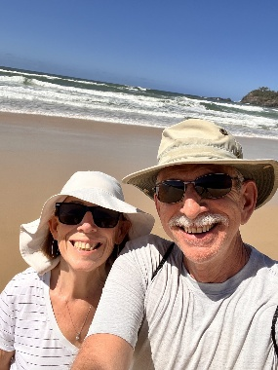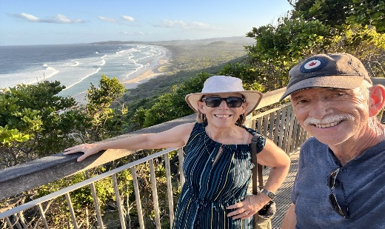
Walking along the Bryon Bay, Capr Bryon, most easterly part of Australia.
Doug & Jane walking along the Australian Sunshine coast

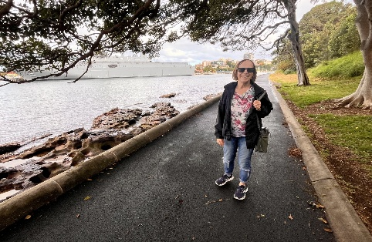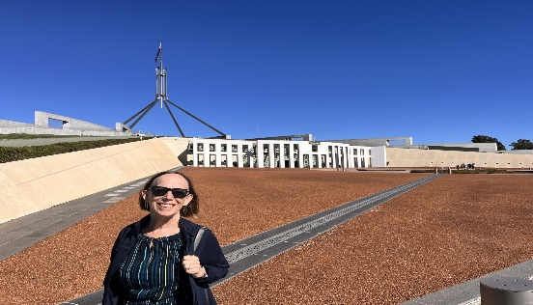

Walk and tour of Parliament House in Canberra
Walking the sea wall in Sydney, Australia’s Botanical Gardens

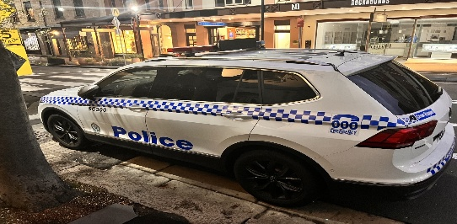
Sydney, Australia police vehicle. Remember, the search is on for various international and unusual police vehicles during the Fit Challenge.

Andrea Lamothe is in third place with a total of 1,163 kms over the 4 moths so far. Andrea is preparing for a marathon, and I am sure at her rate of accomplishment each month, that she will not have a problem during the actual marathon. Good Luck Andrea! Congratulations on your outstanding record.
Mike Pearson has almost completed the Region 6 circumference, short of 22 kms, Mike has completed 688kms. Keep going Mike. Again, another phenomenal Region 6 participant.
The author is still slowly coming out of hibernation from the bitter Ottawa cold. A few photos are shared from the Ottawa downtown displaying the beginnings of spring, which finally turns into summer! Our days are getting longer and brighter. Still waiting for the warmer days.
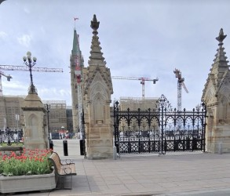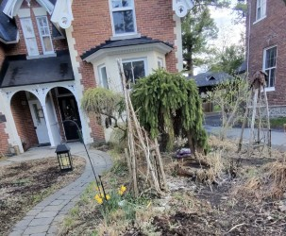
Crocuses beginning to bloom in New Edinburgh neighbourhood
Tulips beginning to blossom in front of the Parliament building

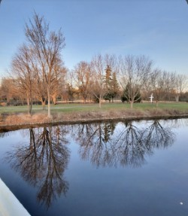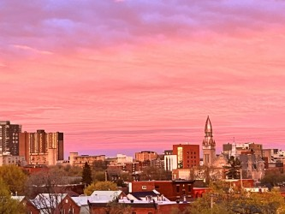
Incredible sunset during the last week of April.
Beautiful reflection in the Rideau River. Still waiting for the trees to bud and leaves appear

Congratulations to all Regional 6 participants and keep it up! As a team, we are now going to be walking across the Baltic regions and detouring a bit to stay out of any of the hostilities, making our way across mid Europe.
Also, do not forget to send in your interesting or brag pictures as you send in your monthly stats. Stay safe, have fun and get out and rack up those kilometers.

Teresa Holmes - IPA Region 6 Fit Challenge

