International Police Association Region 6
Fitness Challenge 2026 – January 2026
Welcome back all and welcome to the newcomers. After a two-year rest and numerous nudging from all around, it was unanimously agreed that we should set out once again on that endless trek of 40,075+ kms, the circumference of the globe. This is no easy feat. A lot of blood, sweat and tears. As we get older, the motivational factor sometimes lags and the couch is our best friend. Perseverance is our new friend.
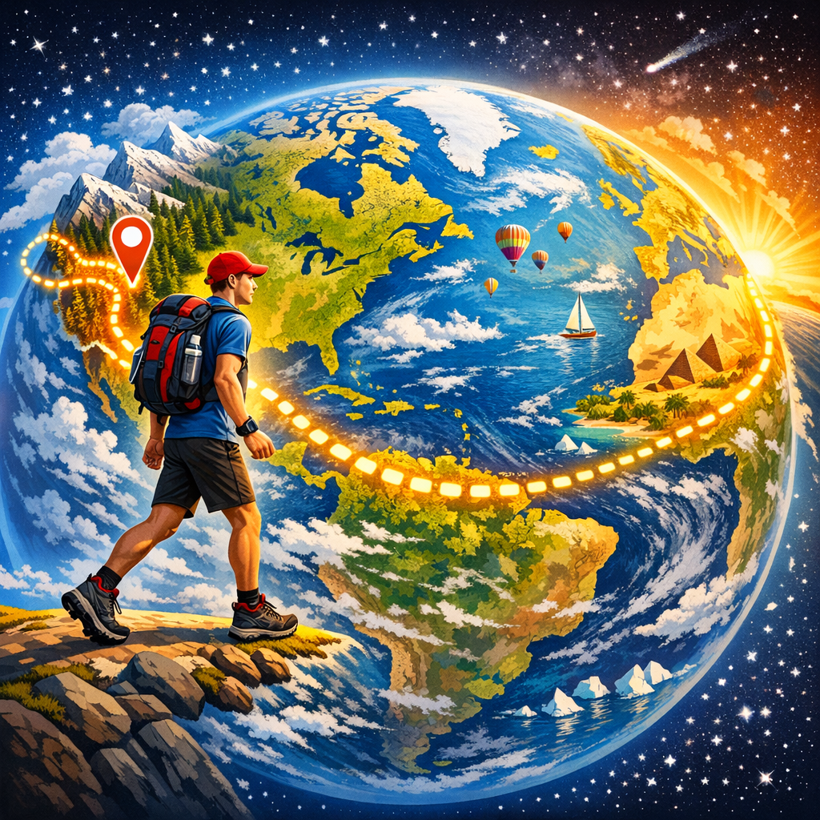
Welcome back Gilbert, Andy, Jim, Doug, Jane, Teresa, Bill, Richard, Anne, June, and Deacon Bill.
Welcome Sharon Lee, Scott, Véronique, Serge, Serhat, Jason, Mike, and John.

Combined, our first month total for January 2026, was an astounding 2,112kms! What a phenomenal start to achieving that 40,000+kms. Only 37,963kms to go! We can most definitely do this! If we want to trek the world within 12 months, we need more help. We need many more IPA Regional 6 members to sign up. Each kilometre counts, each yoga session, each weight lifting session counts. If you want to help achieve this feat, reach out at: IPAR6FitChallenge2026@outlook.com
January 2026, was an exceptionally bitterly, frigid, Bonkers cold month! A massive blast of Arctic air driven by a destabilized polar vortex covered much of Region 6. Daytime temperature plunged consistently around -25C. Combined with a windchill factor it often felt more like -35C! Needless to say, outdoor activity was kept to a minimal. Shack Whacky became a common word and after so many consecutive days of being holed up. Teresa Holmes was one of the few daring ones to brave the elements and get outside, walking around the various downtown Ottawa sights, The trick was to stay completely covered up to avoid frostbite.
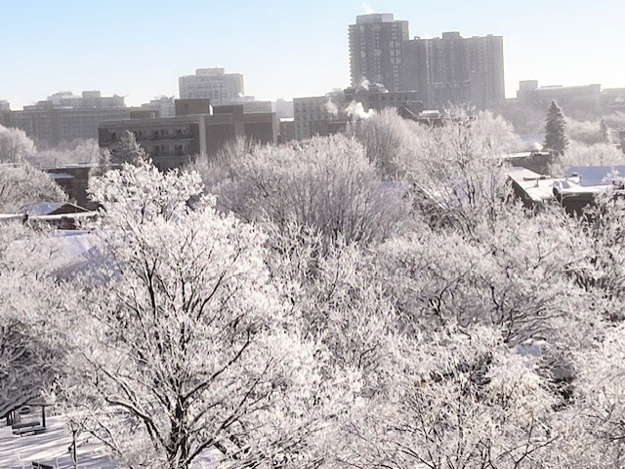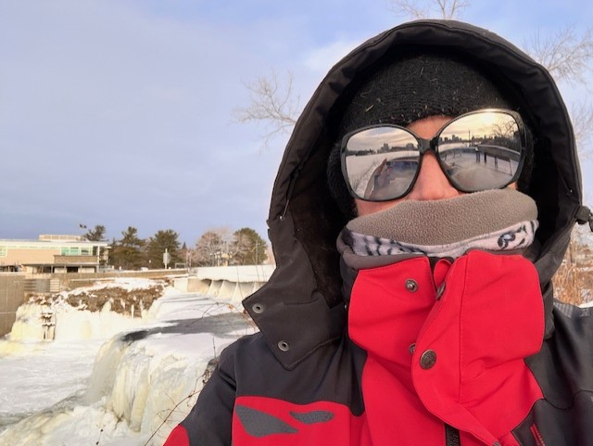
Gilbert Anctil was genius and remained indoors, partaking in swimming, gym workouts and even yoga, accumulating a great 71 kms. If you are doing similar workouts you can verify with ChatGPT or Co-Pilot the equivalent kilometres, or, send the type of workout and times to IPAR6FitChallenge2026@outlook.com
Some of our luckier…or smarter Region 6 members continued to migrate South, part of the great Canadian Snowbird flock. The species that is adverse to cold, snow, frost, shoveling, black ice, snow ploughs, etc; packs up and vamooses to warmer and sunnier weather if not after the first Canadian snowfall, for sure after Christmas. Jim Grant gloried in the sunny coast of Florida, enjoying the surf, golf greens and walking about to his heart’s content. Enjoy Jim! Mike Pearson, another Canadian Snowbird traveled South to Nassau, Bahamas, where he kept busy enjoying the warmer environment and accumulating 176 kms. Quite impressive Mike. Keep up the good work! Doug and Jane Morris were more Snowbirds, choosing to trek through Puerto Vallarta, Mexico. Doug’s final kilometre score was 174 kms, so close to Mike. Jane, on the other hand is also an early bird and walked another 100+kms in the mornings, reaching an impressive 304k ms for her first month. To top off their fantastic scores, Doug and Jane climbed 300 steps to reach the Mirador de la Cruz lookout. What a workout!!!
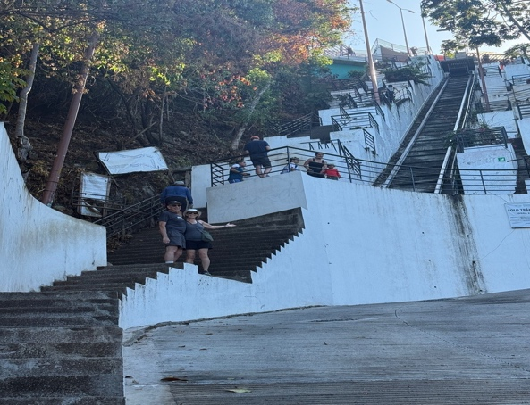
Now, on to our Marvel Superhero, Bill Murrell, who once again blasted everyone’s score out of the water, literally, with a January finale of 629.24 kms! Region 6 circumference is 714kms. In one month Bill almost trekked the entire region circumference. Shout out to Bill and challenge to see if over the course of the Fit Challenge, if he can actually meet or surpass the Region 6 circumference… Note to self, last time I did bet Bill during the previous Fit Challenge, I ended up buying his lunch. Dare I challenge Bill again? Does everyone think Bill can do it?
So, quite a phenomenal start for everyone! Jane Morris our top female and Bill Murrell our Superhero. As I prepare this IPA Region 6 Fit Challenge report, it was yet again another -32C day and I can hear die hard crazy Canucks playing outdoor hockey in the park across the street. I bid you all Congratulations! Quite the impressive start. Have fun! Stay safe and rack up those kilometres.

