IPA Region 6 Fit Challenge
June 2026 Report

June in Ottawa has finally brought our much-beloved summer temperatures. With more rain than normal it has only ensured our lawns, parks, and woods are lush and green. Absolutely no complaints. The warmer weather has also brought more people outside, which has resulted in a nice monthly team score of 1,961.80 kms.

Our total IPA Region 6 Team score to date is 14,121.88 kms. Only 25,953.12 kms to go in order to circumnavigate the world. So far, kilometer speaking “as the crow flies” we are still in western Europe. With the great Atlantic Ocean behind us, we conquered the tumultuous storms and high waves, dodged the great FIFA soccer balls as the various international teams made their way in the opposite direction to Canada, the USA and Mexico. Not slowing down to bask in the historic sites throughout Europe, we trudge onwards towards Russia, with her majestic cities, deserts and mountains.

Much thanks for those members who have provided their missing month totals. I will be sending individual emails as a reminder for missing monthly stats. Six months in and we are stuck at only 20 members. I am sure, with the warmer weather, there is more Region 6 members out there who are getting in some kilometers. Even mowing the lawn, as one of our last event member did during the summer months. Each kilometer counts towards our global 40, 075 kms. If interested in joining our Fit Challenge, you can email IPAR6FitChallenge2026@outlook.com

Bill Murrell got another kick start and boosted his monthly kilometer result up to 600.8 kms. I have yet to conquer that score in 6 months! Meeting Bill at our recent IPA Region 6 Brunch, I did not notice any undue wear and tear on Bill’s physique. He indicated his knees are still holding up. (I even tried to check for nuts and bolts to confirm Bill is indeed the 6 Million Dollar Man)… nada! Don’t ask me how he achieves and maintains these high results, but Bill is certainly instrumental in pushing us all from behind.

Our next top contender is Jane Morris, who consistently achieves approx. 300 or plus kms a month. She literally walks circles around Doug. As always, we are grateful for Doug and Jane’s brag pictures. They enjoyed the month of June in Gibsons, British Columbia, accumulating many kilometers walking along the cobblestone beaches of Howie Sound and climbing the endless stairs up the various cliffs. You too, can send in your brag pictures or just incredible or interesting pictures anytime.

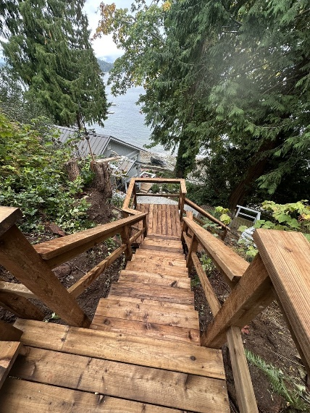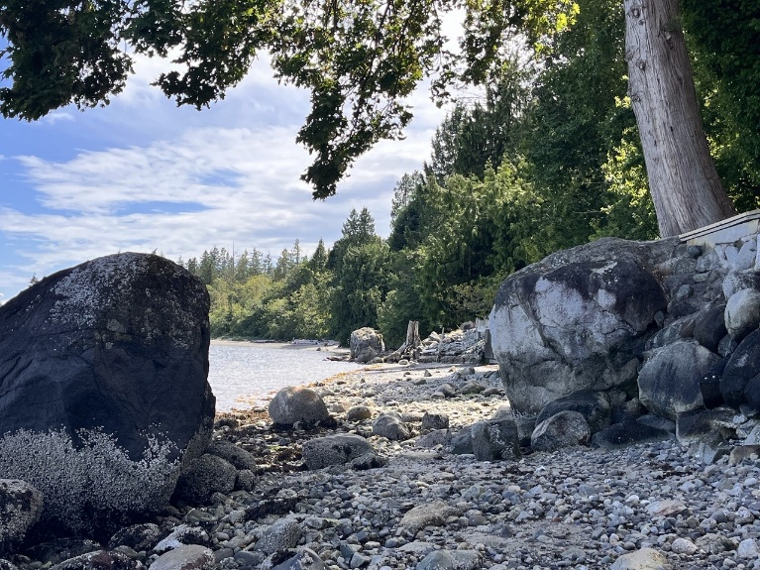

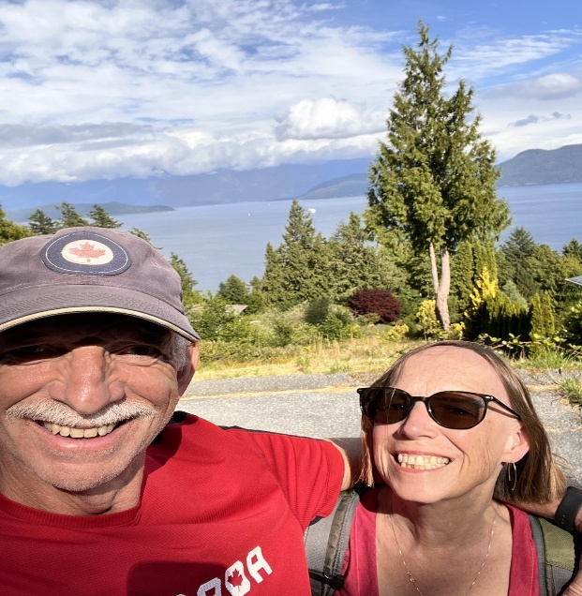

With the warmer weather the author is able to get some steps in and see some inconceivable sites, right in her own neighborhood. Numerous tourists are all over the Byward Market, located in the heart of Ottawa. To increase their police presence and promote their community relations, the Ottawa Police Services have begun daily/nightly horse patrols throughout the Market. They were an enormous hit when they posed in front of the lit up Ottawa sign. It was magical to see people of all ages run up to see and talk with the mounted police, pet the horses and take their selfies. The smiles on all the faces were priceless! On another bright and sunny Ottawa day, the author made her way up and across Ottawa’s own Great Wall, from Major Hill Park to Kiweki Point, behind the National Gallery Museum. At the highest point is seems you can reach out and touch the top portion of Alexander Bridge. The back views of Parliament and upwards to the Ottawa River towards the United Kingdom Embassy and our own 24 Sussex views are equally impressive. A definite adventure for all Region 6 guests.

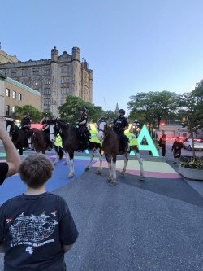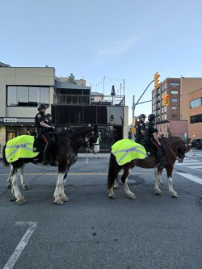

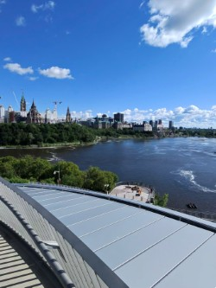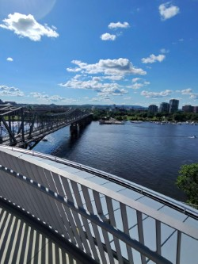
In conclusion, the Region 6 Fit Challengers are doing a fantastic job, all seem to be enjoying themselves and we encourage others to join in on the fun and get a good workout while they are at it. Help us to achieve our goal and in the end, you help yourself by keeping active.
Teresa Holmes/Region 6 Fit Challenge Coordinator

