IPA Region 6 Fit Challenge 2026
July & August 20026

Our continued IPA Region 6 Fit Challenge is combined for the summer months of July & August 2026, as the author was away. It appears a lot of signed-up members were also busy as our monthly reports have drastically trickled down to only 9 members submitting their stats, from 20 registered members. Less than half. We are always happy to obtain backdated stats which will add to our overall goal of circumnavigating the world.
Our original goal is to completely traverse the entire 40, 075 km circumference within 12 months. Last time, during COVID-19, 2022-2023, it took us 18+ months. Trying to strip off the extra six months is possible, however, only if we receive all registered members monthly stats and somehow get a few more IPA Region 6 members to join us. Currently, we at the end of 8 months, have traversed a bit under halfway of the circumnavigation! We have 21,042.78kms left, with only 4 months left to meet this challenge. WE CAN DO IT, with a supreme effort and participation from more Region 6 members. Time to get off our couches, beds, get out of the house and enjoy our cooler weather, with autumn leaves already starting to display their wonder.
Our total combined kilometers is actually 19,023.22 kms. If we departed from the far West British Columbian coastline, we would currently be wandering around Volgograd, Russia, 47.5% of the way around the world. Bill Murrell and Teresa Holmes have both been to Russia, and agree it is quite the country, both historically and immense scenic views. As Russia is vast, we shall probably find ourselves still trekking eastwards by the end of September 2026. We are most definitely heading for the mountain regions with winter nipping at our footsteps.
Our top contender for the summer months was Andy Bakker, who pedaled 800kms for the Ontario Sick Children’s Hospital (CHEO). This is an annual event for Andy, and we most certainly thank him and appreciate his supreme effort! Incredible feat! Still waiting for a response if Andy is able to dance, let alone walk and move after this feat!
Bill Murrell, back in March 2026, nipped just a tiny bit ahead of Andy’s record. Bill managed to clock in 816.98 kms on his stationary bike and rowing machine. How both of these retired members are able to reach these numbers is mind boggling!
Another strong contender and top female member is Jane Morris. Jane has consistently pulled off 300+ kms a month, walking throughout the day, and then a bit more with her husband Doug as they travel throughout the world and enjoy the marvelous scenery, of which they are so gracious to share. This summer found them back in the wet and soggy western coast of British Columbia. During one of their numerous walks along trails and steep stairs they came across a sweet visitor, as shown in the picture. Both are now spending autumn in Ontario. Thanks as always Doug and Jane for your beautiful photos.
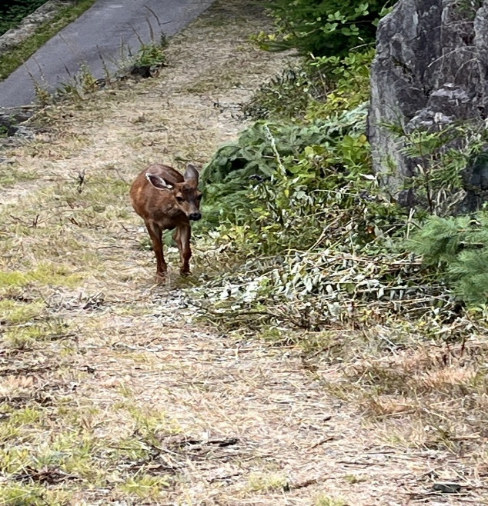

A shout out to our faithful Region 6 members who have faithfully submitted their monthly stats such as Sharon and Scott Anderson, Andy Bakker, Jane and Doug Morris, Bill Murrell, and Mike Peterson, as well as the author. Congratulations on all of your effort, time and dedication.
Speaking of the author, the warmer weather and a family wedding brought the author out of her residence and got her moving. Most summer activities were sidelined by minor and aggravating health issues, but enjoyment was achieved by some swimming sessions, kayaking at her favorite lake in Yarker, Ontario, traveling East to reconnect with the good ol Atlantic Ocean, traveling to her Father’s hometown, in Shelburne, Nova Scotia, where she discovered a distant family name inscribed on the local Fisherman Memorial, and cannot leave walking along the great Halifax waterfront, which was hosting two cruise ships. The author also enjoyed visiting and walking throughout a portable dinosaur park with her grandnephew and grandniece in early July, as well as walking about Canada’s capital on Canada Day, after celebrating a special Mass at Notre Dame Cathedral Basilica.
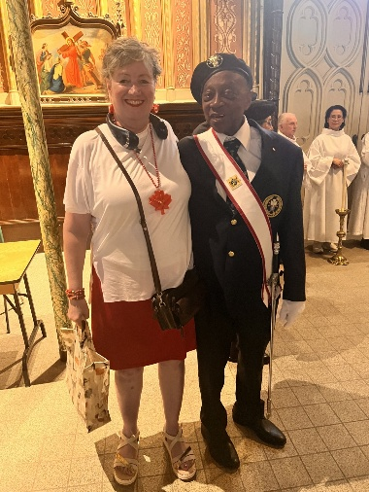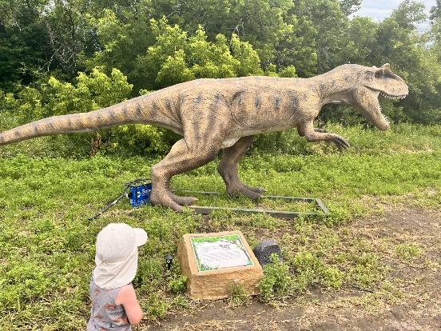

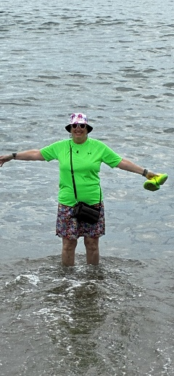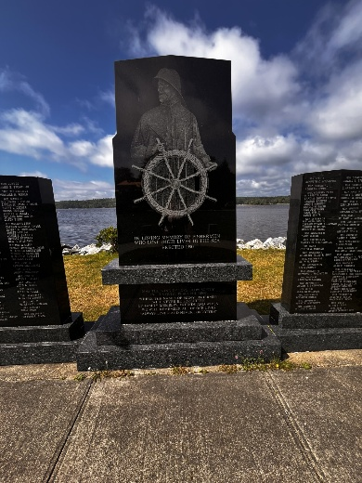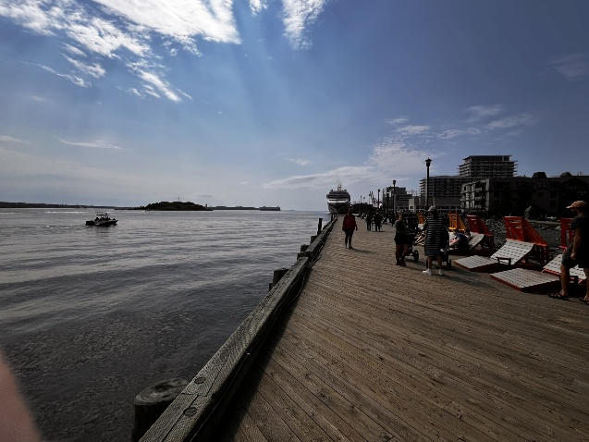
Again, we are always asking and hoping for your brag pictures, or pictures of the world around you as you add those kilometers to your score. Simply sign up and send your stats and pictures to IPAR6FitChallenge2026@outlook.com

