IPA REGION 6 FITNESS CHALLENGE 2026 - TRAVERSE THE GLOBE
FEBURARY 2026

Month two, February 2026, has passed and our Regional Fit Challenge is still warming up for the majority of us. Certainly cannot blame us as the crazy temperatures were consistently below -20C across the region. If you were anything like the author, I championed in the Couch Potato category, finessing various movements of comfort or sleep, while watching the Winter Olympics and racking up the kilometers in my head, watching the winter biathlon, bobsledding or figure skating. Severe adverse reactions to the insane cold outside, I hibernated once again. Sidelined by a cold, my ventures outside were few and far between. Here’s hoping for a warmer March.


Doug and Jane Morris, living in sunshine, beautiful British Columbia, enjoyed the warmer temperatures and took advantage of the bright sunshine to get a few kilometres in. Jane loves to walk each morning while Doug takes advantage of “trying” to get out of bed. Jane is our second highest achiever this month with 585kms! So close to the circumference of our Region 6, which is 710kms. Jane is just shy of 125kms, which I am sure she will surpass, at her rate. Another advantage of living in British Columbia is the incredible scenery as shown off by Doug and Jane at Hopkins Landing.
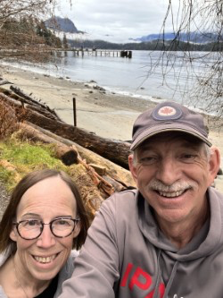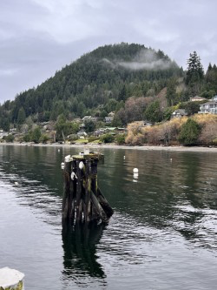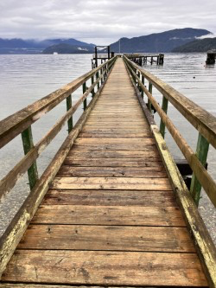
Our third place contender for the month of February 2026 is Gilbert Anctil with a total of 474.6kms in 2 months. Gilbert combines walking, pool swimming and yoga during these winter months, his goal being to increase kilometers each month. His combined swimming and yoga for each month is almost equivalent to 100kms. For those of you who are not enrolled yet and think I do nothing, every little bit helps and Gilbert is proof positive! Way to go Gilbert!
Welcome to our new Region 6 Fitness Challenger, Andrea Lamothe, who is also our Regional secretary. She has an incredible beginning with a total of 366kms in 2 months. As I continue to couch surf it just boggles my mind how everyone is managing these incredible stats!
Our top February contender is once again, Bill Murrell. Bill explained he is quite happy to ride his stationary bicycle while watching Netflix. Now, that is motivation. I think he must be watching repeats of Chariots of Fire, Superman, Thor and maybe some of the winter Olympics. Bill sure got the gold, if there was medal standings for his top stats of 680.17kms in February! A reminder of Bill’s January stats of 629.24, which total 1,309.41kms so far! I think that is the author’s year end goal, if I am lucky. I see I will have to up my game.
For those of you who have yet to send in your February results, there is still time. Email them to IPAR6FitChallenge2026@outlook.com Always lots of room for other members to join in and help us circumnavigate the globe. We only have 35,548kms left. Remember, family can also be enrolled, as we already have a few couples. Even children and grandchildren of IPA Region 6 members can join. Get everyone involved.
In two months, as a team effort, we have managed to traverse Canada from the Pacific Ocean in British Columbia, covering 4,5226.91kms, which brings us to Montreal, Quebec! Just in time for the Winter Carnival in Old Quebec and lots and lots of poutine. Bill Murrell certainly earned it, as well as all of us for putting in an excellent effort once again. By end of March 2026, we should be starting the swim across the Atlantic Ocean, on our way to Europe. Nothing can stop us now.
Can we reach the challenge of 40,075kms in one year? Absolutely! We can with your help. Every step, every kilometre helps and double bonus as any activity keeps us fit and healthy. We got one new member for the month of February. Lets try for 5 new members during the month of March. Drag another Regional member out. Maybe when it does get warmer we can look at group walks followed by a refreshment or two. There are lots of trails around our Region. That will be a challenge we will work on in the upcoming months.

Until the end of March, keep up the incredible work. So impressed by all of the stats and the warmer weather is only a few weeks away. Let’s get some spring in our step and fly, rather than swim across the Atlantic Ocean.

Teresa Holmes
R6 Fit Challenge Coord

